Monkeys:

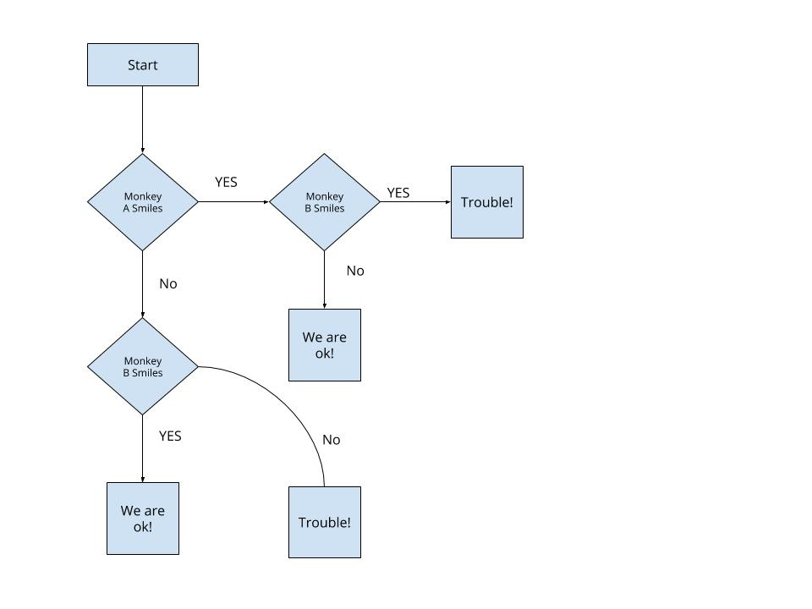

Good Dogs:

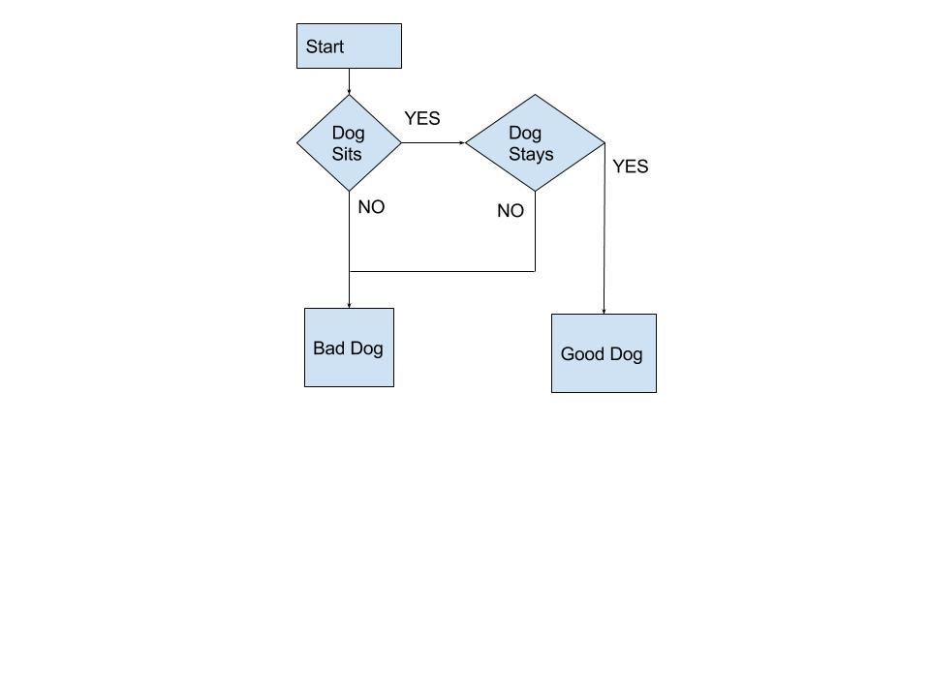

Numbers:

IF A greater than B

IF A greater than C

A is largest

ELSE

C is largest

END IF

ELSE

IF B greater than C

B is largest

ELSE

C is largest

END IF

END IF

Ticket:

IF SPEED greater than 60

IF SPEED greater than 80

big ticket

ELSE

little ticket

END IF